Bringing in An Effect from CapCut
PART 1 — CREATE THE EFFECT IN CAPCUT
- Open CapCut
- Create a new project

Add your effect ONLY
- Drop in the “glitter fall” effect
- No background footage if possible

IMPORTANT SETTINGS:
- Make background BLACK
- Make glitter bright (white or warm)

How to Blend our Shadows into the black for Transparency
Effects come in with an off black, and we need to blend that in, and get it to be black in order to get transparency.
In Color Page (on the glitter clip):
Add a node and do this:
Alt-S
- Lower Lift (shadows)
👉 pull it down until background disappears
- Increase Contrast slightly
- Adjust Gamma carefully
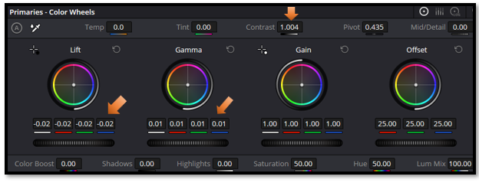

Turn the Opacity on the Edit page, in the Inspector down a bit.
